

­

**Module Code & Module Title**

**CS5053NI/CC5068NI– Cloud Computing & IoT**

**<<Project Title Here>>**

**Assessment Type**

**10% Proposal Report**

**Semester**

**2023 Spring/Autumn**

**Group members**

|  |  |
| --- | --- |
| **London Met ID** | **Student Name** |
|  |  |
|  |  |
|  |  |
|  |  |
|  |  |

**Assignment Due Date:**

**Assignment Submission Date:**

**Submitted to: Mr. Sugat Man Shakya**

**Word Count:**

*I confirm that I understand my coursework needs to be submitted online via Google Classroom under the relevant module page before the deadline in order for my assignment to be accepted and marked. I am fully aware that late submissions will be treated as non-submission and a mark of zero will be awarded*

**Acknowledgement**

First and foremost, we’d like to thank our module leader Mr. Sugat Man Shakya for giving us the platform to work on an Internet of Things (IoT) project on the topic **“Toll Tax Gate”** and also for assisting us throughout the journey of project completion. Special thanks to Mr. Ayush Pradhanang sir for guiding us through detailed process and feedbacks during the tutorial classes. Making this project a success was an interesting yet challenging task which made us go through various topics, learn everything in detail. This project would have never gotten this shape if our mentors didn’t guide us through the path.

We are very grateful towards the college fraternity, lecturer and tutor for letting us work on a group which helped us build communication skills. Irrespective of busy schedules and timings, we were assisted by the best of our mentors during all the small phases of development. We are very thankful towards each of our group members for being a cooperative and understanding fellows. Mutual understanding and proper discussion within the team has been the key factor in the development process which we are immensely proud of.

**Abstract**

There isn’t a proper Toll System in Nepal that has been implemented, even if it’s implemented or so, it is not really technology driven that automatically detects any vehicles and open the barrier on its own.

Technology has been a crucial factor in everyone’s lives currently. The major objective behind the development of this gadget is to help run a smoother traffic control, seamless vehicular movement in city areas, automated tax collection system, etc. This gadget automatically detects any vehicular movement when a vehicle comes in front of the Ultrasonic sensor and eventually opens the barrier for the vehicle to move forward. Vehicular reports can be generated to see as to how many vehicles run on a day and implement various rules and regulations in accordance to that. This could be the crucial invention in order to have a best Traffic Control in the cities like Kathmandu. “Toll Tax System” is one of the exemplary innovations in the filed of Internet of Things (IoT). This technology is intended to make an exact replica of Toll Plazas. The idea behind this project is inspired from an actual Toll Plaza which is doing so very good in the market as a technology.

It is the combination of the work of Ultrasonic sensor and Servo Motor serving as an actuator that responds to the instructions of the sensor. The motor is activated when a vehicle passes in front of the sensor. The major components of the project are: Arduino Uno, Ultrasonic sensor, Servo Motor, Breadboard. This system is intended to make it an easier task to collect funds and taxes.

**Table of Contents**

**Table of Figures**

**Table of tables**

# Introduction

The term Internet of Things (IoT) denotes a system where physical devices are linked and communicate with each other over the internet. These devices, ranging from household appliances and wearables to industrial machinery, are equipped with embedded sensors, software, and other technologies, allowing them to gather and exchange data. In this project, we have also used the power of IOT to build a prototype of toll tax system which is a simple yet very useful system. Here, we use ultrasonic sensor, Arduino Uno, some wires, Arduino IDE and a servo motor to operate the task (ORACLE, 2023).

Internet of Things (IoT) has made it possible for the users to create a seamless connection among processes, things and people. Digital Systems have been able to respond, record, and interact between interconnected things on Internet. The impact of IoT has been expected to be more than $10 trillion by 2025 and more than 100 billion interconnected IoT devices. IoT devices and applications use machine learning algorithms to control huge amount of interconnected sensor data.

Automatic Toll Tax System is an example of on of the IoT devices that automatically opens a gate for vehicle once the tax has been paid. This formulates an easier and seamless traffic control, enhances security and easier tax collection. Various benefits can be extracted from the system such as time management. Various components such as ultrasonic sensor, breadboard, servo motor, jumper wires, Arduino UNO R3 are used during the phase of development. The Ultrasonic sensor is expected to pickup signals from vehicles, measure its distance and return the distance back to the sensor which then responds in accordance with the returned value. Servo Motor starts to operate if the vehicle is within the distance of Ultrasonic sensor’s threshold.

## Current Scenario

Introducing a tax collection system marks a significant step for the nation to embrace automation and progress. Implementing an automated toll tax system would be an excellent initiative, enabling vehicles to make digital tax payments. Upon payment completion, a sensor would detect the vehicle’s approach, allowing it to pass through the barrier seamlessly, with the barriers unlocking automatically once the transaction is confirmed. This streamlined process enhances efficiency and contributes to the overall advancement of the nation.

The Road Board Nepal (RBN) implemented toll tax system in Nepal from 2018’s fiscal year where vehicular movement exceeding 900 units per were imposed a certain amount of money. Two-wheelers to pay Rs.10, Heavy vehicles to pay Rs.60 and light vehicles Rs.20 in Narayangadh-Hetauda Section in Nepal. It was later raise to be Rs.110 for heavy vehicles and Rs.60 for light vehicles. Rs.200 million annual tax collection is being done since then every year which is a massive rise after the raise in various taxes.

* In the US, electric approach for toll collection is used i.e. E-ZPass. A transponder is attached to the vehicle which is then scanned as the vehicle passes through toll ways. The deduction of amount is done from the prepaid account of the owner of the vehicle.
* Europe Toll road, i.e. Dublin Ring Road, Denmark: Oresund Bridge linking Copenhagen and Malmo.
* Australia (E-TAG), is one of the examples of toll roads which is being used for automatic tax collection.
* Toll Booths in Asia are found on highways in countries like India, i.e. National Highway Authority of India (NHAI).

## Problem Statement and Project as a Solution

Gathering taxes to promote the well-being and advancement of the nation has consistently played a crucial role in the development process. The toll tax system serves several practical purposes and benefits, contributing to efficient transportation management and infrastructure development. Although manual tax collection may appear to be a viable solution, automating the tax collection process with reduced manpower is the most efficient approach. In Nepal, traditional methods involving physical barriers, such as tires, are still prevalent for stopping vehicles to collect taxes on roads. Given the current state of our country, our team has devised an automated toll tax system as a progressive alternative.

In context of Nepal, there’s been an irrational traffic specially in city area, mostly Kathmandu. Reduce Traffic Congestion, Real-time Monitoring, Transparency, Digital Payment would be possible if the project would be implemented in Kathmandu. Since the population density here in Kathmandu is high, implementation of Toll Tax System would enhance clean and open city. Specially during the rush hours, people face a lot of problems because of Traffic congestion and delays. By accepting local payment methods and technology driven automation, the system contributes to transparent and user-friendly toll tax collection in the context of Nepal.

The project’s major goal is to create an automatic toll tax gate. It is expected to track the distance of the vehicle that comes in front of it. Actuator then responds to the input data sent by the sensor. Servo Motor is programmed such that it’s given directions to operate on a certain angle or a direction.

## Aims and Objectives

### Aims

The primary aim of the project is to make it an easier task for people for efficient revenue collection and to reduce traffic congestion.

### Objectives

The major objectives of this project are as follows:

* Convenient experience for better traffic management
* Cost Efficiency and reduction in time
* Automation in the field of Tax collection
* Security enhancement by adopting encrypted communication.
* User-friendly approach
* Reduce traffic congestion and impose better tax collection system.
* Impose a real time monitoring system for improved management.
* Adoption of Digital Payment reduces the irritation of having to carry cash.

# Background

This study concludes that the implementation of a toll tax system facilitates easy tax collection. We used a variety of components, including an ultrasonic sensor, a servo motor as the actuator, and a breadboard to temporarily connect wires on a prototypic level, to produce a completely functional toll gate in this system.

## System Overview

The strategy aims for building a toll tax gate, addressing issues with traffic congestion, upholding transparency, implying automation, real-time monitoring, and many other things. When a car gets close to the sensor, the toll tax gate opens. After completing the required transaction, the system identifies all types of automobiles.

Using a servo motor, which responds to commands from code uploaded to the Arduino Board, one can modify the movement of the gate. The object's distance is detected by the ultrasonic sensor, which then relays the information back to itself. In this module, the servo motor serves as the output device, and the actuator receives the necessary information to rotate its propeller from the ultrasonic sensor. General Purpose Input Output Pins are used to programme the Arduino Uno with C++ code, which subsequently provides specific instructions to the various components attached to the circuit board (GPIO).

The car moves along a road, and at one end of the road is an ultrasonic sensor that detects the presence of vehicles. The gate is positioned just behind the sensor and opens automatically, assisted by a servo motor, whenever a vehicle passes in front of it.

**DESIGN PICTURES GO HERE.**

The system needs the following resources: a computer to code, an Arduino IDE for text editing, Tinkercad for circuit design, an Arduino Uno R3 Module for uploading the code, and any type of basic computing specifications for the computer.

## Design Diagrams

Design diagrams, which have helped us along the way, can be used to forecast different prototypic stages of development processes. We may get a basic sense of how the system would appear from the scenario provided below.

### Block Diagram

Figure Hardware Architectures

### 2.2.2 Flow Chart

### Circuit Diagram

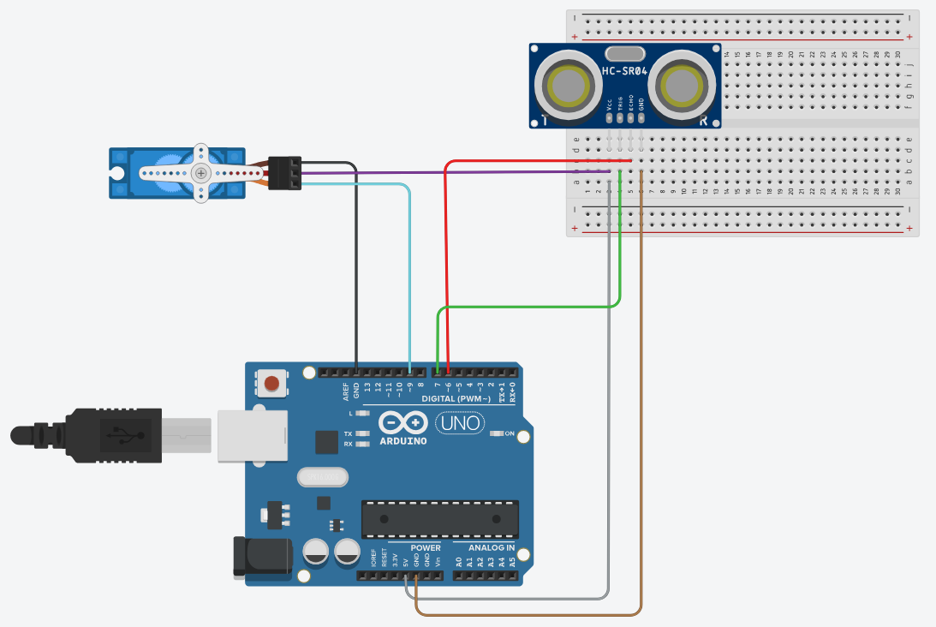

### 2.2.4 System Architecture

### 2.2.5 Schematics

## Requirement Analysis

### Hardware Components

* **Arduino Uno:**

Arduino Uno has fourteen GPIO pins. This microcontroller has fourteen GPIO pins. Using a USB cable to connect to a computer is necessary. It features an EEPROM, a battery connector, and a swappable chip. It is able to assign an actuator to the output results based on inputs from various sensors (arduino, 2023).

The best microcontroller is this model since it can store data and/or codes, decode data from connected sensors, respond to codes, and determine what needs to be done by an actuator. It is readily accessible and reasonably priced. It is therefore the best microcontroller for this project.

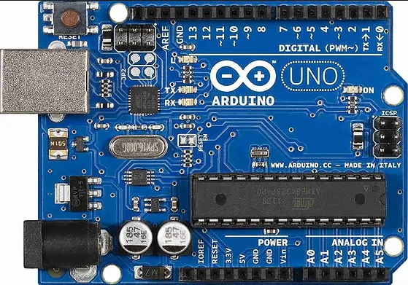

Figure Arduino Uno R3

* **Breadboard:**

A breadboard is used to create a temporary circuit with wires. Because it makes it simple to remove components from the circuit, it is incredibly practical. Using this would make prototyping simpler. Typically, a socket has five rows. It is composed of wire-containing plastic blocks. To facilitate the flow of electricity, the sockets are internally attached to the board (Schousek, 2018).

Since we only need to temporarily connect the wires, this is the most feasible design board for the project. For permanent purposes, soldering cannot be done in its current state. That makes it the most appropriate for this project.

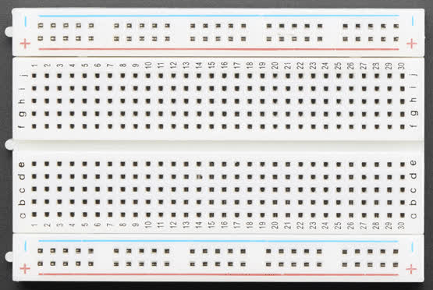

Figure Breadboard

* **Jumper Wires:**

These are the wires that can be used without soldering because they have distinct connectors on both ends. These are the wires that can be used without soldering because they have distinct connectors on both ends. These are used in conjunction with a breadboard to facilitate use during the prototyping stage. Male-to-Male, Male-to-Female, and Female-to-Female are the three categories in which they fall. It can come in a variety of colours that, while usually meaningless, can be utilised to distinguish between different kinds of connections, such as ground, etc (Hemmings, 2018).

These cables don't require soldering to connect to any components, which makes them ideal for our project since it's meant to be constructed temporarily. It also made it easier for us to temporarily connect various components together.

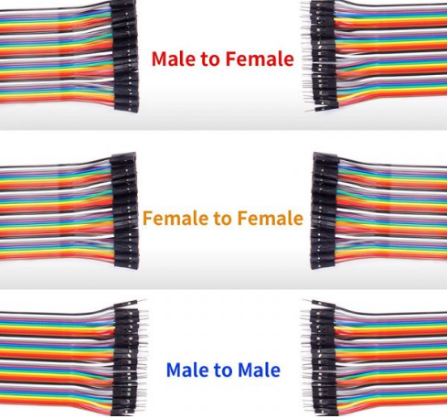

Figure Jumper Wires

* **Servo Motor:**

Servo motor is made up of a motor, potentiometer, and controlling unit that gives feedback on the motor pole's present position. This part is made up of a motor, potentiometer, and controlling unit that gives feedback on the motor pole's present position. This tool is quite useful for turning an object at a particular angle. The Servo Mechanism powers it. The gear configuration in this motor facilitates the generation of a high torque (Apoorve, 2015).

This motor is the best suited for our Toll Tax Gate as our gate required to only open on a certain angle in a certain direction. Since, servo motors can be coded to rotate around its propeller in accordance with what the desire is, it is the best suited than the other motors.

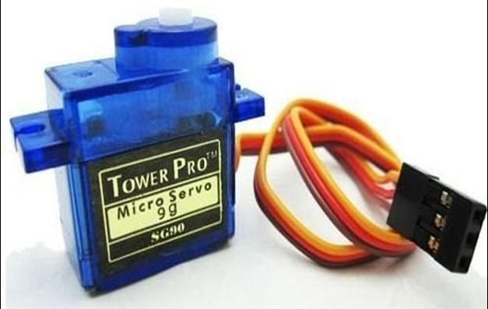

Figure Servo Motor

* **Ultrasonic Sensor:**

An ultrasonic sensor is a part that sends and receives ultrasonic sound waves using a transducer to provide information about the distance of an item. The purpose of this part is to detect vehicle movement. A sensor detects vehicles automatically and relays the information to the microcontroller for additional processing whenever a vehicle approaches in front of it (MaxBotix, 2023).

The greatest advantage to use a sensor is we require the ultrasonic sensor in the toll tax gate to measure the vehicle's distance and transmit the results back to the microcontroller.

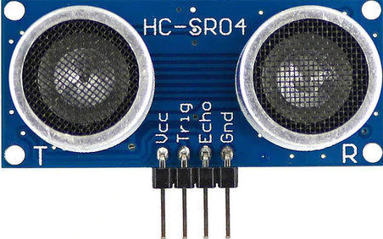

Figure Ultrasonic Sensor

### Software Components

* **Arduino IDE:**

To write code and upload it to an Arduino board, we utilise this free and open-source editing programme. There are multiple download alternatives available for diverse Operating Systems (OS). The source code is hosted on GitHub and is available for contribution by the wider community because it is open source. It also supports all of the latest Arduino Boards and comes with a number of libraries (arduino.cc, 2023).

* **Tinkercard:**

It is a free web app for circuit designing, 3D designing, etc. It helps the users to electronically simulate different circuits before connecting the components in real life. This reduces the risk of short-circuit and damage of property.

# Development

The step-by-step processes of the entire development phases are described under this particular section. Various phases such as planning, recourse collection, system development and uploading the code are mentioned below.

## Step 1: Planning and Design

All the team members were involved during this phase of our project. We had many ideas on various IoT projects to work on. Vision is very important in every phase of development, mostly during the initial phase. Proper planning was done before finalizing the project. We considered various ideas such as automatic et feeder, flame detection system, etc but we finalized “Toll Tax Gate” eventually.

We had already collected items for Automatic Pet Feeder during the initial phase of planning, but due to lack in resources and ideas, we planned to change the topic and it was later finalized to be “Toll Tax Gate”. The idea behind the selection of this project was to end the irrational Traffic management just like in Naubise, Kathmandu.

As we all know, the current Traffic management of Kathmandu is very poor, implementing “Toll Tax Gate” would at least make it a bit easier for the residents to pay taxes digitally, smooth vehicular movement, etc. Since we are at the of technology, digitizing in this particular sector would also be a smart move to enhance better traffic control and security.

In the early designing phase, Tinkercad was used in order to create a fully functioning circuit design. It helped us understand the components even more clearly and their operational processes removing all the casualties and potential damages that could have happened due to lack of knowledge during the development phase.

## Step 2: Resource Collection

Various resources were used to develop the 3D model of this project. The resources were collected from the Resource Department of Islington College itself. We got all the necessary requirements from the college’s Resource Department itself. This task of collecting the required components was given to our group leader, Swagat Gautam. Various resources collected from the Resource Department are:

* Arduino Uno R3
* Jumper Wires
* Breadboard
* Ultrasonic Sensor
* Servo Motor.

## Step 3: System Development

**Phase 1:**

A circuit design was created using Tinkercad in this phase of development process which helped us simulate between the components and get a brief overview of the components. It was then transferred to the real components by connecting them to breadboard.

## 3.4 Step 4: Uploading the code to Arduino Uno and running the program

# Results and Findings

## Results

After the completion of designing and system development phases, it was time to check if the system is working properly. For that, we needed to upload the code to the Arduino board and see the results. The gate should open whenever there’s an object in front of the gate. The gate should only open when the object is inside Ultrasonic Sensor’s distance threshold and vice versa. Various tests are done under this segment. It was seen for the gadget to be working absolutely fine as the barrier (gate) got opened whenever any object came in front of it. The code is written in such a way that the object has to be within Sensor’s threshold to be able to properly detect its distance and open the gate. Actuator that is Servo Motor in this project, works such that it opens the barrier at an angle of 90 degrees vertically whenever there’s a detection of object in front of the sensor. Transducer detected the object and sent its distance back to Arduino, the microcontroller. This gadget can be set in the roads just like the toll plazas do. In order to implement on a larger scale in real life. For that it should be developed with proper planning and resources should be collected with fundings as well.

**2 PARAGRAPHS**

## Findings

Different truth and falsity of the system is to be measured in order to come to a conclusion that the system is completely working. For that various truth and false testing have been done for the system which are mentioned below:

### Test 1: To demonstrate the code is running properly without any errors.

|  |  |
| --- | --- |
| Test No: | 1 |
| Objective: | To show the code is running properly without any errors. |
| Action performed: | Code was written, compiled and uploaded on Arduino Uno on Arduino IDE software. |
| Expected Result: | The code should be compiled without any error and uploaded to the Arduino board. |
| Actual Result: | The code was compiled and worked successfully on the Arduino board. |
| Result: | Test was successful. |

Table Test 1

### Test 2: To demonstrate that the gate opens when an object approaches the distance threshold of an ultrasonic sensor.

|  |  |
| --- | --- |
| Test No: | 2 |
| Objective: | To demonstrate that the gate opens when an object approaches the distance threshold of an ultrasonic sensor. |
| Action performed: | An object was brought near Ultrasonic sensor’s distance threshold. |
| Expected Result: | The gate should open vertically, 90 degrees to the ground. |
| Actual Result: | The gate opened vertically, 90 degrees to the ground. |
| Result: | Test was successful. |

Table 2 Test 2

### Test 3: To demonstrate that the gate is not opening when object is outside of Ultrasonic sensor’s distance threshold.

|  |  |
| --- | --- |
| Test No: | 3 |
| Objective: | To demonstrate that the gate is not opening when object is outside of Ultrasonic sensor’s distance threshold. |
| Action performed: | An object was taken away from Ultrasonic sensor’s distance threshold. |
| Expected Result: | The gate should not be not opening at all. |
| Actual Result: | The gate did not open at all. |
| Result: | Test was successful. |

Table 3 Test 3

### Test 4: To demonstrate that if a car arrives in the other direction of the gate, the gate will not open.

|  |  |
| --- | --- |
| Test No: | 4 |
| Objective: | To demonstrate that if a car arrives in the other direction of the gate, the gate will not open. |
| Action performed: | An object was brought from the other direction of the gate. |
| Expected Result: | The gate should not be opening at all. |
| Actual Result: | The gate did not open. |
| Result: | Test was successful. |

Table 3 Test 4

### Test 5: To demonstrate that if a car is on hold near the ultrasonic sensor, the gate remains open for it.

|  |  |
| --- | --- |
| Test No: | 3 |
| Objective: | To demonstrate that if a car is on hold near the ultrasonic sensor, the gate remains open for it. |
| Action performed: | An object was kept near the ultrasonic sensor on hold. |
| Expected Result: | The gate should open when the object is on hold near the ultrasonic sensor. |
| Actual Result: | The gate did open. |
| Result: | Test was successful. |

Table 3 Test 5

# Future Works

For a prototypic model, this system is a fully functional on a very smaller scale. This project could be greatly enhanced to surpass its current state. Since this project is only a smaller representation of what it would look like on a larger scale, it may also be referred to as the tip of the iceberg. Even though it is small, its power allows it to approximate what it would appear like if it were larger. This project can be upgraded greatly to benefit individuals in their future pursuits.

Upgrades such as implementing permanent components using larger scale of ideas would be reasonable. The upgrade could help people save the vehicular movement in a database saving all the details of different vehicles by integrating a camera on it or counting the number of vehicles on each opening of the barrier. This would help keep track of all the vehicles travelling on a particular location. Tax collection, traffic security and management on a larger scale would also be possible if upgraded wisely.

Various future works that could be carried out are listed down below:

* Creating an application to store data of the vehicles in a database.
* Use the concept of Cloud Computing to integrate data and secure them for future references.
* Attach a camera with the software that’d also save the vehicle’s pictures for safety purposes.
* Machine learning could be implemented to implement predictive maintenance of the system.
* Capital could be invested on enhancing security and privacy factors to be safe from potential vulnerabilities.
* It can be made full electric and not dependent upon any kinds of fossil fuels to make it environmental-friendly.

# Conclusion

In conclusion, as Internet of Things (IoT) is at its peak of development, it has already seen a lot of development processes during its phase of growth worldwide. From the very first IoT device being the Toaster invented by John Romkey in 1990 AD to automating almost everything in 2023 AD, it has definitely seen a long way of development.

Developing an Automatic Toll Tax Gate using Arduino Uno, Ultrasonic sensor and Servo Motor has proven to be a significant step towards the modernization of toll plazas and traditional toll collection system. The implementation of the concept of IoT on this project has shown a seamless impact on the traffic management, control, security and smooth tax collection. We successfully implemented and integrated various hardware components together in order to build this project and get the end result of what it looks like today. Arduino Uno serving as a microcontroller, Ultrasonic sensor as a transducer to detect object’s distance, servo motor serving as an actuator to respond to the outputs given by the Arduino board.

It is seen for the system to be working seamlessly in the real world scenario as well even though it’s just a prototype of what could be built in the future endeavours. IoT is currently at its pinnacle of development as it is seen to be booming world wide. Various smart gadgets are being launched on a daily basis, many new inventions have been made throughout the period of time. There are certainly the areas for the future improvement in various factors of the project. Upgrades such as implementing permanent components using larger scale of ideas would be reasonable. The upgrade could help people save the vehicular movement in a database saving all the details of different vehicles by integrating a camera on it or counting the number of vehicles on each opening of the barrier. This would help keep track of all the vehicles travelling on a particular location.

In a nutshell, this project has laid its foundation of what the larger scale of Toll Tax Gate would look like. Successful integration of various parts/components such as Arduino Uno, Ultrasonic Sensor, Servo Motor, Breadboard, Jumper Wires shows the potentiality of these small scale components for various innovation purposes in many areas of IoT development. Various development and research process can be conducted in order to successfully integrate and implement the improvements on a larger scale.

# References

# Appendix

## 8.1 Appendix A: Source Code

## 8.2 Appendix B: Screenshots of the System

## 8.3 Appendix C: Design Diagrams